Control Statements

* Conditional statements

1. if statements
2. if-else
3. nested if-else
4. if-elseif ladder
5. switch-case 2``

* Unconditional Statements

1. break
2. continue
3. goto

* Looping Statements

1. While loop
2. Do-while loop
3. For loop

if(condition)

{

if(condtion)

{

}

else

{

}

}

else

{

if(condition)

{

}

else

{

}

}

if(condition)

{

Statements

}

else if(condition)

{

Statements

}

else if(condition)

{

Statements

}

else if(condition)

{

statements

}

else

{

Statements

}

if(a>10)

{

}

Else if(a>15)

{

}

Else if (a>20)

{

}

Else

{

}

switch(c)

{

case 1:

statements;

break;

case 2:

statements

break

case 3:

statements

break

default:

statements

}

c==1

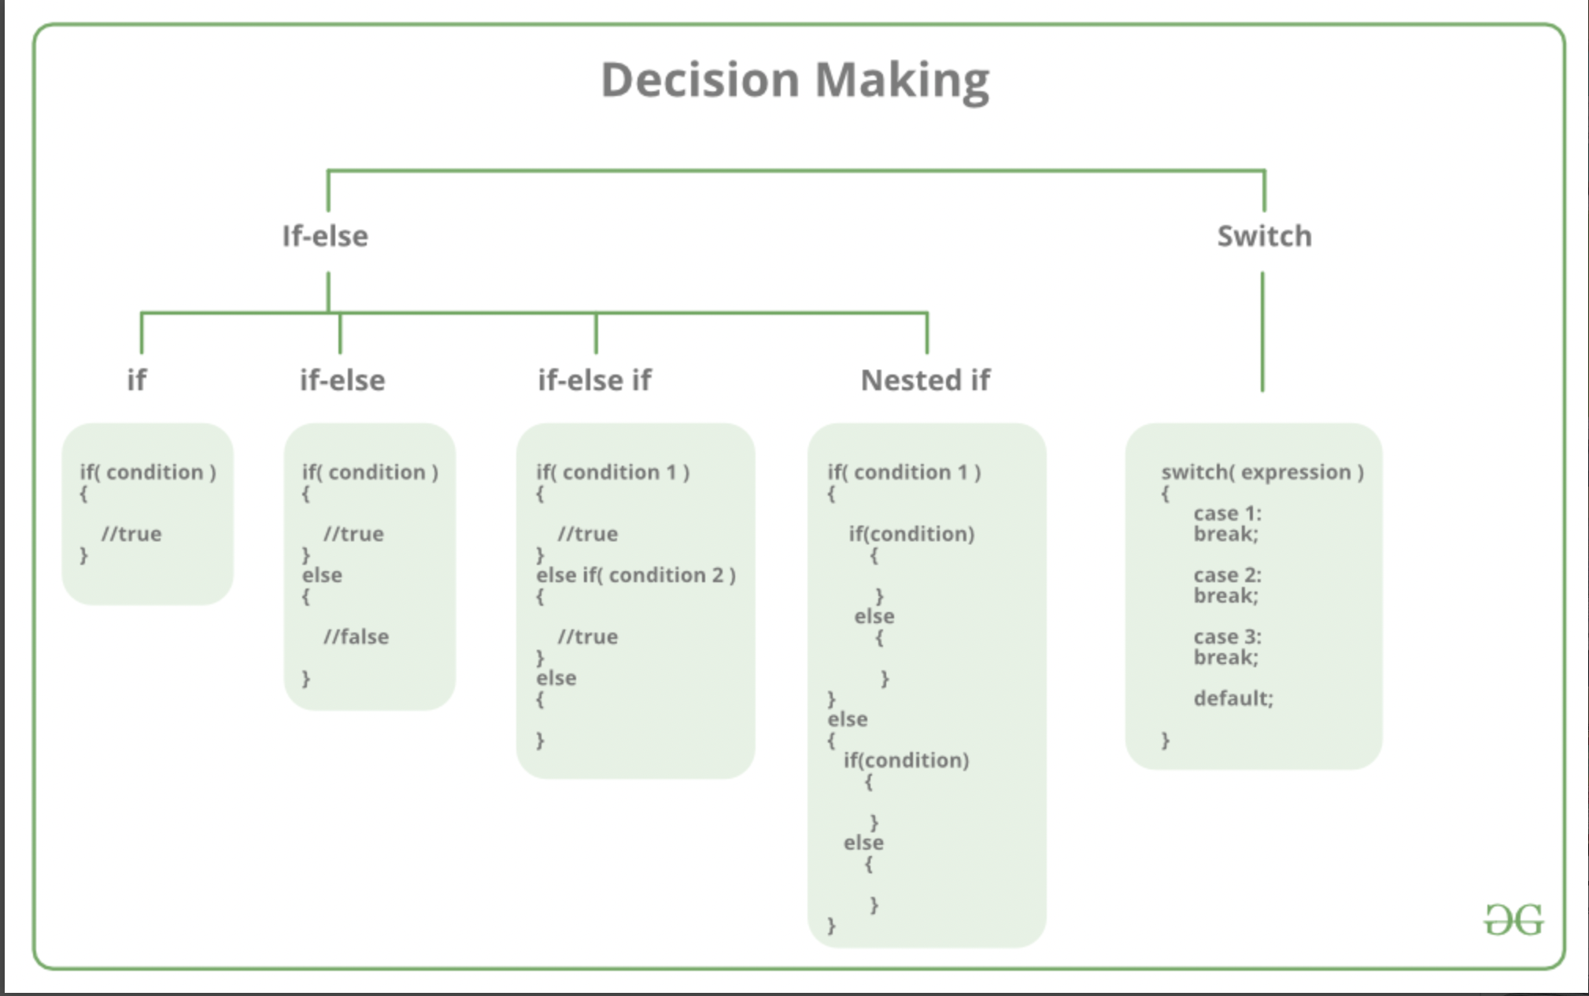

**PROGRAMS**

**Write a program to take input of a number and check whether the number is odd`` or even.**

#include <iostream>

using namespace std;

int main()

{

// Write C++ code here

int no;

cout << "Enter the number : ";

cin >> no;

if((no % 2) == 0)

{

cout << "The number is Even";

}

else

{

cout << "The number is Odd";

}

return 0;

}

**Write a program to take input of a person’s age and according to age, you have to print the message whether user can vote or not.**

#include <iostream>

using namespace std;

int main()

{

int age;

cout << "Enter the age of a person : ";

cin >> age;

if((age > 100) || (age < 0))

{

cout << "\n Invalid Age";

}

else

{

if(age >= 18)

{

cout << "The person can vote";

}

else

{

cout << "The person cannot vote";

}

}

return 0;

}

**Write a program to take input of two numbers and display the larger one.**

#include <iostream>

using namespace std;

int main()

{

int no1, no2;

cout << "Enter first number : ";

cin >> no1;

cout << "Enter second number : ";

cin >> no2;

if(no1 == no2)

{

cout << "\n Both numbers are equal.";

}

else

{

if(no1 > no2)

{

cout << no1 << " is larger.";

}

else

{

cout << no2 << " is larger.";

}

}

return 0;

}

**Write a program to find maximum/largest number from 3 numbers.**

**Using if statements**

#include <iostream>

using namespace std;

int main()

{

int no1, no2, no3;

cout << "Enter first number : ";

cin >> no1;

cout << "Enter second number : ";

cin >> no2;

cout << "Enter third number : ";

cin >> no3;

if(no1 >= no2 && no1 >= no3)

{

cout << no1 << " is larger.";

}

if (no2 >= no1 && no2 >= no3)

{

cout << no2 << " is larger.";

}

if (no3 >= no1 && no3 >= no2)

{

cout << no3 << " is larger.";

}

return 0;

}

**Using Nested if-else statements**

#include <iostream>

using namespace std;

int main()

{

int no1, no2, no3;

cout << "Enter three numbers: ";

cin >> no1 >> no2 >> no3;

if (no1 >= no2)

{

if (no1 >= no3)

{

cout << no1 << " is largest number.";

}

else

{

cout << no3 << " is largest number.";

}

}

else

{

if (no2 >= no3)

{

cout << no2 << " is largest number.";

}

else

{

cout << no3 << " is largest number.";

}

}

return 0;

}

**Using elseif ladder statements**

#include <iostream>

using namespace std;

int main()

{

int no1, no2, no3;

cout << "Enter three numbers: ";

cin >> no1 >> no2 >> no3;

if (no1 >= no2 && no1 >= no3)

{

cout << no1 << " is largest number.";

}

else if (no2 >= no1 && no2 >= no3)

{

cout << no2 << " is largest number.";

}

else

{

cout << no3 << " is largest number.";

}

return 0;

}

**Write a program to print student’s result by taking input of 3 subject marks, finding percentage depending on the below condition:**

* **Percentage > = 80 then “Distinction”**
* **Percentage >= 70 then “First class”**
* **Percentage >= 50 then “second class”**
* **Percentage >= 40 then “Pass”**
* **Percentage < 40 then “Fail”**

#include <iostream>

using namespace std;

int main()

{

int sub1, sub2, sub3, per;

cout << "Enter three subject marks: ";

cin >> sub1 >> sub2 >> sub3;

per = (sub1+sub2+sub3)/3;

if(per >= 80)

{

cout << "DISTINCTION";

}

else if(per >= 70)

{

cout << "FIRST CLASS";

}

else if(per >=50)

{

cout << "SECOND CLASS";

}

else if(per >=40)

{

cout <<"PASS";

}

else

{

cout << "FAIL";

}

return 0;

}

**Write a program to take input of two numbers and depending on the choice given (Addition, Subtraction, Multiplication, Division), perform the operation on that numbers and display the result.**

#include <iostream>

using namespace std;

int main()

{

int no1, no2, ans, choice;

cout << "Enter two numbers : ";

cin >> no1 >> no2;

cout << "\n 1. ADDITION \n 2. SUBTRACTION \n 3. MULTIPLICATION \n 4. DIVISION";

cout << "\n Enter choice : ";

cin >> choice;

switch(choice)

{

case 1:

ans = no1 + no2;

cout << "\n Addition is: " << ans;

break;

case 2:

ans = no1 - no2;

cout << "\n Subtraction is: " << ans;

break;

case 3:

ans = no1 * no2;

cout << "\n Multiplication is: " << ans;

break;

case 4:

ans = no1 / no2;

cout << "\n Division is: " << ans;

break;

default:

cout << "\n Enter valid choice.";

}

return 0;

}

while Loop —----> Entry- Controlled Loop

do-while Loop —---> Exit-Controlled Loop

while(condition)

{

statements

}

do

{

statements

}while(condition);

#include <iostream>

using namespace std;

int main()

{

int no=5;

while(no > 0)

{

cout<< "\n This is C++ lecture.";

no = no-1;

}

return 0;

}

#include <iostream>

using namespace std;

int main()

{

int no=5;

do

{

cout<< "\n This is C++ lecture.";

no = no-1;

}while(no > 0);

return 0;

}

Write a program to print numbers 1 to 50.

Write a program to print numbers in multiples of 10(example: 10,20,30,...)

Write a program to take input from the user and print that number’s multiplication table.

Example:

2 x 0 = 0

2 x 1 = 2

2 x 2 = 4

2 x 3 = 6

2 x 4 = 8

2 x 5 = 10

Conditional statement /Conditional Operator/ Ternary Operator

A + b

A - b

? :

Int a,b,c;

cin>>a>>b;

if(a>b)

{

c=a;

}

Else

{

c=b;

}

cout<<”Maximum no.: “<<c;

c= (a>b) ? a : b;

cout<<”Maximum no.: “<<c;

Cast operator / type cast operator

Int a = 10;

Float b = 100.25;

Float c;

C = a + (int)b;

Pattern programs